Consumer Ed
April 13-17

What you will need:
Computer/device
Internet
School e-mail/Microsoft TEAMS

What you will do:
M 4/13 | T 4/14 | W 4/15 | Th 4/16 | F 4/17
Turn-in Final Portfolio (if you did not do this last week)  Add a photo of YOURSELF to our Teams classroom | Watch Video and take notes 1.1 Key Components of Financial Planning (13 min) | Watch Video and take notes 2.1 Money, the American Way (15 min) | Watch Video and take notes 3.1 You and Money (13 min) | Complete the Assignment: Ch 1 What is Personal Finance
Use the boxes below to CHECK when above task is completed (optional):

What you will learn:
Why personal finance is important, how Americans relate to money, and how you can identify your money personality and apply it to your financial life.

How you will complete your work:
Add a Photo:
We miss you and it will be great to see your face! Add a NICE and school appropriate photo of yourself to our Teams classroom!

- Go to your Team classroom. In the upper right corner, click the circle for your profile. Click “Change picture”
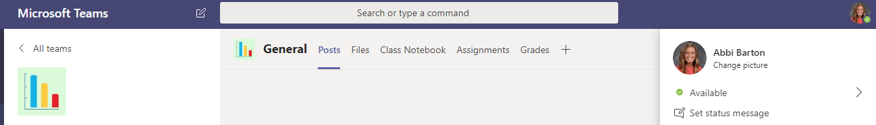

- In the next window, click “Upload picture.” Find the photo saved in your files.

Don’t have a photo? EMAIL ME! I will send you your yearbook photo

Watch Foundations Digital Videos and Take Notes:
- Instructions for watching Foundations Digital are in Teams. Go to “Files” > Open the “Class Materials” folders > “Foundations Digital_ConsumerEd”

- Watch the videos and take notes in your workbook. If you do not have your workbook, take notes on paper. Choose topics that are new to you or seem very important to remember. If you notice Dave repeating something, write it down; that means it’s important. Individual note taking is an excellent skill to practice for college!

COMPLETE “CH 1 WHAT IS PERSONAL FINANCE?” AND TURN-IN
- Go to ASSIGNMENTS and open the attached document. You can:
  - Type your responses and upload your document OR
  - Hand write your responses and take a photo to upload

- You will find directions for turning-in assignments under Files > Class Materials > Microsoft Teams Instructions

abarton@northmacschools.org
“See” you next week

